<Name>
<Address>
<Address>

<Date>

General Manager
Georges River Council
PO Box 205
HURSTVILLE NSW BC 1481
By email: mail@georgesriver.nsw.gov.au

Submission: Mortdale Local Centre Master Plan
Reference: SF21/3419

I have been a resident of Mortdale for <number of> years, and am writing to object to, and express concerns about the Mortdale Local Centre Master Plan. I choose to live here because of the village atmosphere this suburb provides for my family, who have all grown up in this area.
I oppose the Mortdale Local Centre Master Plan in its entirety for the following reasons:
- Over recent years, road traffic in <Name of> Street has increased significantly, as has roadside parking for commuters using the public rail network. Should the proposal be approved, and high density housing established in the area, road traffic will again increase significantly, and roadside parking will be further reduced due to the increased number of driveways required to service the new housing.
- The unsightliness of “flats” or multi-storey dwellings being built. It is a future slum/ghetto in the proposed planning stages. Regardless of the façade of the building and the code they will be built to, does not detract from the unsightliness of such buildings. I use the areas in and around Hurstville, Kogarah, Rockdale, Wolli Creek, Liverpool, Caringbah and other areas that have high rise and low level multi-storey buildings as examples of the ugliness of high density living.
- The Mortdale/Penshurst areas are already awash with three-storey flats, which are at best, an eye-sore. Although the following is not an exhaustive list of “flats” in the area, it highlights the need to refrain from adding any more to the area:

- Penshurst – Austral Street (between Penshurst St and Ocean St)
- Penshurst – Victoria Avenue (between Penshurst St and Ocean Lane)
- Penshurst – Ocean Street (between Victoria Ave and Forest Rd)
- Penshurst – Ocean Lane (between Victoria Ave and Junction St)
- Penshurst – St Georges Rd (between Austral St and Forest Rd)
- Penshurst – Nelson St (between Austral St and Forest Rd)
- Mortdale – Jersey Ave (between Newman St and Junction St)
- Mortdale – Newman St (between Jersey Ave and Ocean St)
- Mortdale – Pitt St (between Boundary Rd and Morts Rd)
- Mortdale – George St (between Boundary Rd and The Strand)
- Mortdale - Macquarie Place (between Boundary Rd and Morts Rd)
- Mortdale – Martin Place (between Boundary Rd and Morts Rd)
- Mortdale – Oxford St (between Boundary Rd and Morts Road)
- Mortdale – Station St (between Boundary Rd and Morts Rd)
- Mortdale – Mutual Rd (between Cox Place and Morts Rd)

- Residents that have purchased their properties, have done so due to the family friendly atmosphere the area still provides. High density buildings destroy that atmosphere by literally cramming people on top of one another for no real gain or benefit to the residents. The only beneficiaries of the proposals outlined in the Mortdale Local Centre Master Plan will be the State Government (with increased stamp duty revenue for the number of units sold per lot number), Georges River Council (with increased council rates revenue for the number of units sold per lot number) and the utility companies (with increased water, gas, electricity and internet revenue for the number of units occupied per lot number).

- Negative impact of the huge height increases - the height increase in the existing and new B2 Commercial Zone, which will permit buildings 28m (9-storeys) high, will dramatically change the face of the suburb and will destroy the local village atmosphere forever. In addition, the high-rise buildings will impact on the adjoining residential zones through overshadowing, privacy, traffic, parking and visual intrusion.

- Negative impacts of the Mortdale RSL proposed development (Mortdale Gardens) - the Mortdale RSL Planning Proposal, comprising 3 x high-rise towers comprising of approximately 170 units on the upper levels above the 1,800 square metres of retail on the lower levels, and incorporating a large supermarket and specialty shops will direct shoppers away from the existing businesses in the Mortdale Village on Morts Road and has the potential over time to create a ghost town effect on Morts Road.

The Mortdale RSL, NSW Market Potential & Economic Impact Assessment, June 2020, attempts to show the advantages of Bankstown Sports Club and Revesby Workers Club in defence of the Mortdale Gardens proposal. Anyone who has attended either venue, will acknowledge the traffic congestion at both venues. Motor vehicle traffic in Greenfield Parade and surrounding streets is heavy at most times, particularly peak periods in entering the car park at Bankstown Sports Club, and the traffic along The River Road is heavy passing through Revesby shopping centre to attend Revesby Workers’ Club. Mortdale would be adversely affected with traffic congestion due to the one-way streets of Macquarie Place and Pitt Street, bringing unwanted commercial traffic to a residential area.
The following page illustrates the ghastly proposal of “Mortdale Gardens” on the site of Mortdale RSL, which does not fit in with the theme of Mortdale from the Mortdale RSL, NSW Market Potential & Economic Impact Assessment, June 2020.
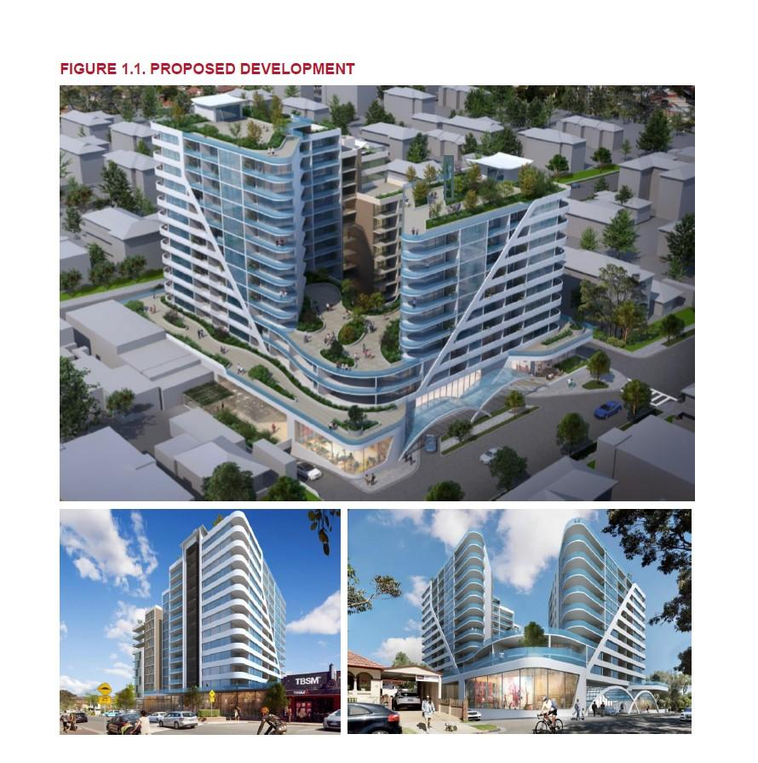
Below is a comparison table showing the increasing population density of Mortdale from Australian Bureau of Statistics for 2006, 2011 and 2016.
Mortdale | 2006 | 2011 | 2016
Area | 252 ha./2.52sq. km | 252 ha./2.52/sq. km | 252 ha./2.52/sq. km
Population | 9,641 | 9,702 | 10,419
Density/sq. km | 3,825 | 3,850 | 4,134
Density per hectare | 38 | 38 | 41

Below is a comparison table of Dwelling Structures from Australian Bureau of Statistics for 2006, 2011 and 2016. It clearly illustrates the decrease in single type dwellings/separate houses, and an increase in flats/units/apartments almost equaling separate houses. The

Dwelling Type | 2006 | 2011 | 2016
Separate House | 1,851 (47.4%) | 1,712 (45.5%) | 1,617 (43.1%)
Semi-detached, terrace house, townhouse | 486 (12.1%) | 519 (13.8%) | 604 (16.1%)
Flat, unit or apartment | 1,350 (39.2%) | 1,490 (39.6%) | 1,514 (40.4%)
Other dwelling | 34 (0.9%) | 38 (1.0%) | 5 (0.1%)
As can be seen by the above figures for Mortdale from the Australian Bureau of Statistics, Council and State Government have been increasing high density housing, even though they said they wouldn’t.

I will conclude with a statement from the then Member for Oatley, Kevin Greene (now Mayor of Georges River Council) in a letter dated 10 September 2010.

“Protecting Our Suburbs

You may be aware of a discussion paper recently circulated by the staff of Hurstville City Council regarding the possible re-zoning of some streets in Mortdale.

In the 11 years, I have been your Local Member of Parliament there has been no rezoning that would increase the amount of unit developments in your suburb.

That means NO additional streets can be used for high-rise unit development.

While ever I am your Local Member I will:

- Fight to ensure that our suburbs are protected from overdevelopment.
- Fight to ensure that this Government will not force increased zoning densities against the wishes of our local community.

My track record of protecting our suburbs from overdevelopment speaks for itself. I must say the track record of Hurstville Council over the last ten years has been pretty good on this issue too. High-rise development has been restricted to the CBD and kept away from our suburbs. It must remain this way.”

Councillor Greene, as Mayor, do you stand by your statement of 10 September 2010?

There is no justification for this drastic increase in zoning, density and building heights in the Mortdale Local Centre and as such this Master Plan should be rejected by Council.

Kind Regards,
<Name>

